**DAILY ONLINE ACTIVITIES SUMMARY**

|  |  |  |  |  |  |  |  |  |
| --- | --- | --- | --- | --- | --- | --- | --- | --- |
| **Date:** | **9-6-2020** | | | | | **Name:** | **poojashree** | |
| **Sem & Sec** | **8th sem A sec** | | | | | **USN:** | **4al16cs065** | |
| **Online Test Summary** | | | | | | | | |
| **Subject** | | **bda** | | | | | | |
| **Max. Marks** | | **30** | | **Score** | | | **27** | |
| **Certification Course Summary** | | | | | | | | |
| **Course** | **Introduction to cyber security** | | | | | | | |
| **Certificate Provider** | | | **Great learning academy** | | **Duration** | | | **5.5hr** |
| **Coding Challenges** | | | | | | | | |
| **Problem Statement:**  **1.** **c program to print pascals triangle** | | | | | | | | |
| **Status:completed** | | | | | | | | |
| **Uploaded the report in Github** | | | | | **yes** | | | |
| **If yes Repository name** | | | | | **Poojashree** | | | |
| **Uploaded the report in slack** | | | | | **yes** | | | |

**Online test**

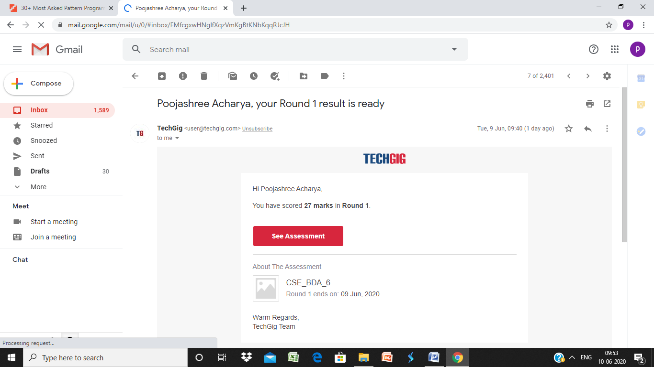

**Certification course**

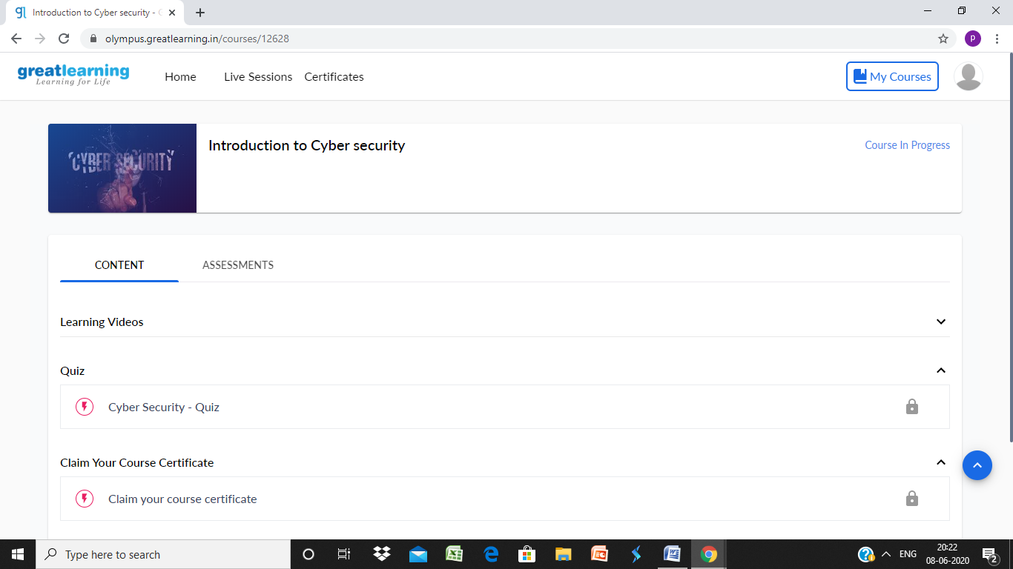

**Coding**

**Program 1**

**#include<stdio.h>**

**int main()**

**{**

**int rows, coef = 1, space, i, j;**

**printf(“\nEnter the number of rows : “);**

**scanf(“%d”,&rows);**

**printf(“\n”);**

**for(i=0; i<rows; i++)**

**{**

**for(space=1; space <= rows-i; space++)**

**printf(” “);**

**for(j=0; j <= i; j++)**

**{**

**if (j==0 || i==0)**

**coef = 1;**

**else**

**coef = coef*(i-j+1)/j;**

**printf(“%4d”, coef);**

**}**

**printf(“\n\n”);**

**}**

**return 0;**

**}**